CAT Image Review Process - Harvey

# Objective:

* Identify the easiest and quickest way to get an outsourced solution up and running to review CAT images to ensure that vehicle images are Ready for Sale
* Ready for Sale means:
  + Buyers can properly evaluate the vehicle from the images
  + Providers see images that are in-line with high-level expectations
* Not a full audit of whether images meet Flood Services SLA’s

# Method:

* Outsourced review of images
* Review will be on the entire set – if one image fails, set is failed (would pricing change if we rejected by image vs set?)
* Review grade is Pass or Fail

# Criteria:

* All 10 images are present and in the correct sequence
  + 1 - Passenger Front
  + 2 - Driver Front
  + 3 - Driver Rear
  + 4 - Passenger Rear
  + 5 - Interior Front
  + 6 - Damage Close-up (could be anything for Flood vehicle without body damage or Flood Services Description)
  + 7 - Odometer
  + 8 - Interior Rear
  + 9 - VIN
  + 10 - Engine
* Entire vehicle is visible – (not too particular on angles as long as vehicle is not cut-off)
* All 10 images are of the same vehicle
* Glare does not obscure vehicle
* Shadow does not obscure vehicle
* Vehicle is de-trashed removed
* No license plate is visible
* Vehicle Body Parts are inside vehicle (e.g. bumper across the backseat)

# Examples:

## Standard 10 Images and Order

Passenger Front

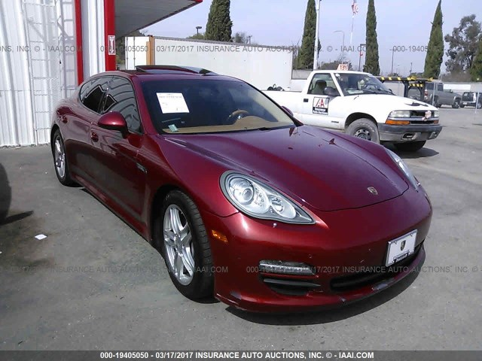

Driver Front

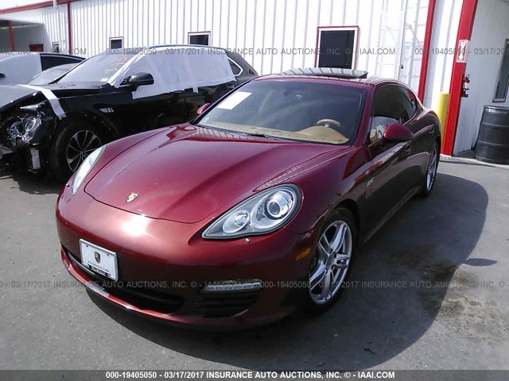

­ Driver Rear

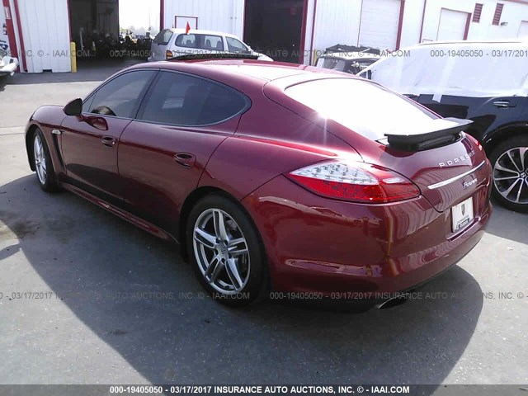

Passenger Rear

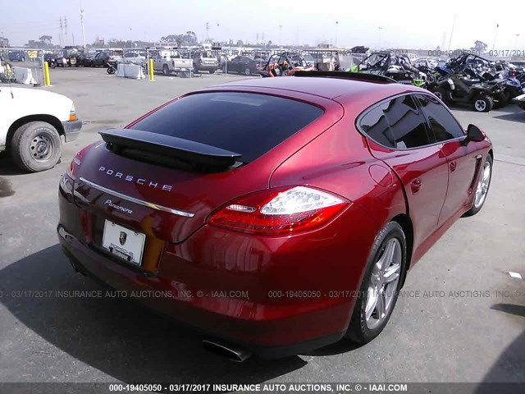

Interior Front­

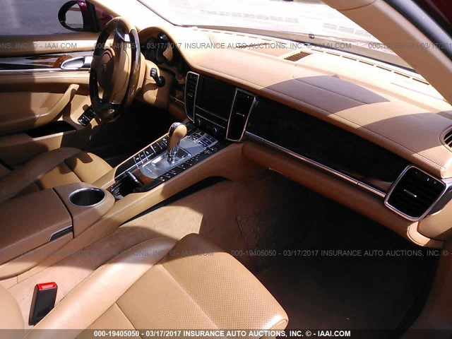

Damage Close-up

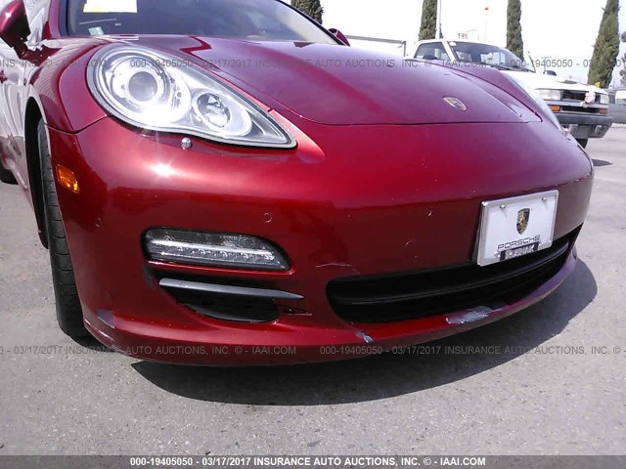

Odometer

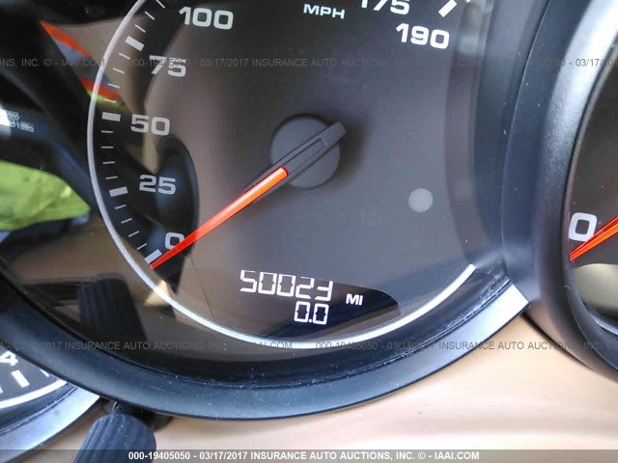

Interior Rear

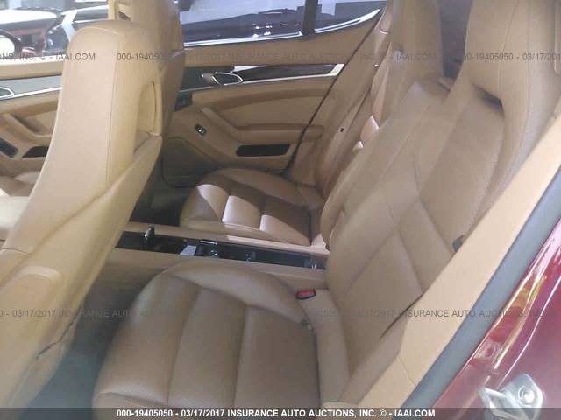

VIN

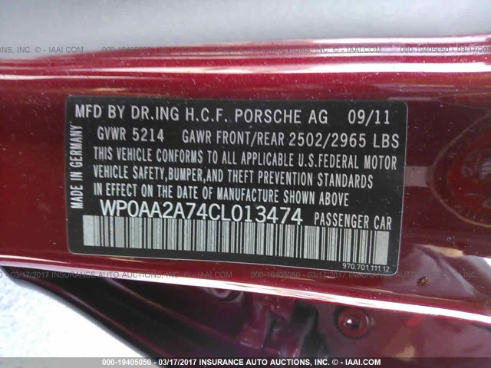

Engine

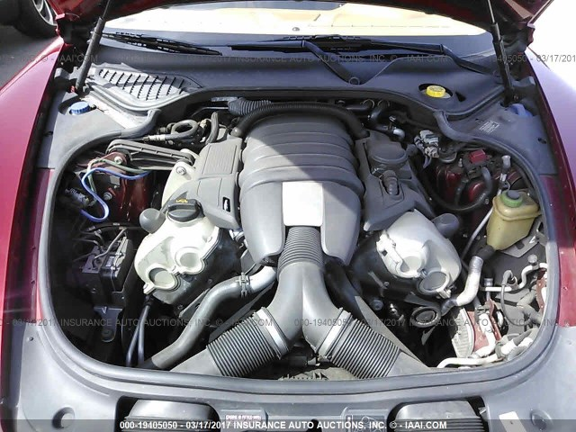

## Entire vehicle is visible

## All 10 images are of the same vehicle

## Glare does not obscure vehicle

## Shadow does not obscure vehicle

## Vehicle is de-trashed removed

## No license plate is visible

## No vehicle body parts are inside vehicle